A000-MEX-Aztec-Zultepec-Mask-Bone-1520

\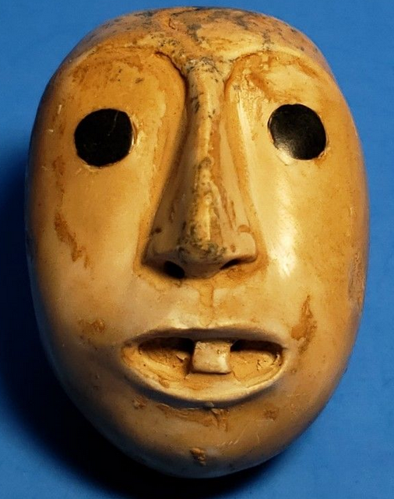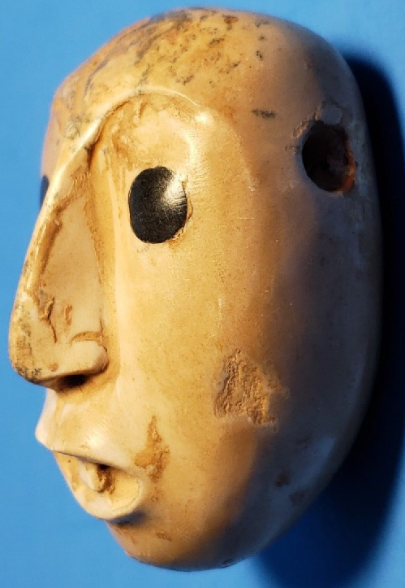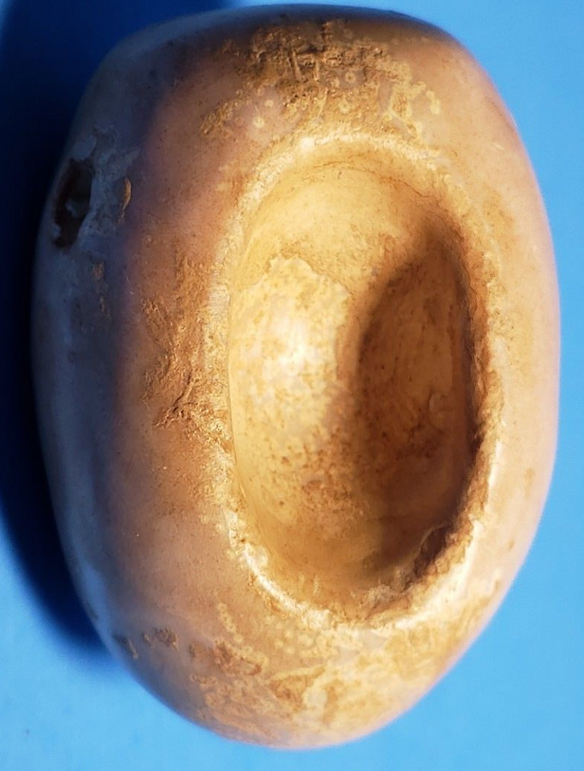

**Case No.: 14**

**Accession No.**

**Formal Label:**

**Display Description:**

This mask represents one of the Zultepec citizens who encountered the Spanish Conquistadores with wide open eyes of astonishment of their gleaming body armor, horses and weapons. Initially, the Aztecs welcomed the Spaniards because they believed that they were their returning gods. Montezuma suspected them to be “divine envoys” of the god Quetzalcoatl, who was prophesied to return in 1519 on the Aztec calendar. The Spaniards were led by Hernan Cortes who took advantage of the Aztecs, by taking Montezuma hostage, where he could control the empire through him. But behind this apparently naieveté of the Aztec was an alert warrior group who recognized how bloodthirsty Cortez and his men were. Through deceit the Zultepec citizens decided to defeat the Spaniards at their own game. Therefore. This maskette encompasses the only time in the history of the Spanish conquest that he Spanish were defeated thoroughly and an apparent “masque” of naieveté! .This mask was possibly carved of human bone—bone of one of the Conquistadors the Zultepecs defeated!

Zultepec was an [Aztec](https://en.wikipedia.org/wiki/Aztec) town which had many white-stucco temples and was the home to approximately 5,000 people, mostly priests and farmers. Aztec warriors captured a caravan of Spanish conquistadors as they traveled to [Tenochtitlan](https://en.wikipedia.org/wiki/Tenochtitlan) in 1520 in response to the murder of [Cacamatzin](https://en.wikipedia.org/wiki/Cacamatzin" \o "Cacamatzin), King of Aztec city,Texcoco. The Aztecs imprisoned the Spanish caravan and over the course of six months, several hundred Spaniards were sacrificed, tortured and partially eaten. The bones found shows that about 550 victims had their hearts ripped out during ritual offerings as well as hard their bones boiled and scraped clean.[[1]](http://articles.latimes.com/2006/aug/26/science/sci-aztec26)

Sacrifice of the Conquistadors continued over six months. When Cortes found out what was being done to his people in Zultepec he renamed the town Tecuaque which means "where people were eaten" in the indigenous [Nahuatl language](https://en.wikipedia.org/wiki/Nahuatl_language). He then sent an army to destroy the town.

References[[edit](https://en.wikipedia.org/w/index.php?title=Zultepec&action=edit&section=1" \o "Edit section: References)]

[Aztec Massacre](https://www.pbs.org/wnet/secrets/episodes/aztec_massacre/1/), [Secrets of the Dead](https://en.wikipedia.org/wiki/Secrets_of_the_Dead), [PBS](https://en.wikipedia.org/wiki/PBS) series (first broadcast: 23 April 2008).

[From](http://articles.latimes.com/2006/aug/26/science/sci-aztec26) [Reuters](https://en.wikipedia.org/wiki/Reuters) (August 26, 2006), "Aztecs Tortured, Ate Spaniards, Bones Show".

[[4]](https://www.independent.co.uk/news/world/americas/montezumas-revenge-cannibalism-in-the-age-of-the-conquistadors-413272.html),"[Montezuma's revenge: Cannibalism in the age of The Conquistadors]",David Usborne,(25 August 2006)

[[5]](http://www.history.com/this-day-in-history/aztec-capital-falls-to-corts),"[Aztec capital falls to Cortés]",History Channel website

**Accession Number:**

**LC Classification:**

**Date or Time Horizon:**

**Geographical Area:**

**Map:**

**GPS coordinates:**

**Cultural Affiliation:**

**Media:**

**Dimensions: H** 2 ½ in,  W 1 ½ in

**Weight:**

**Condition:**

**Provenance:**

**Discussion:**

**References:**